
Contact

Send you Cv’s to job@mazco.com.sa

Or

Post Box: 2486, Dammam 31451,
KINGDOM OF SAUDI ARABIA.
Tell: +966 3 8260080 EXT: 31
Fax : +966 3 8266618
Website::www.mazco.com.sa

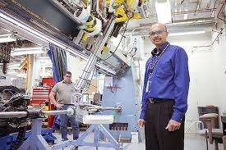
JOB DESCRIPTION
Lab Technician Shall
- Operate processing equipment and instruments
- Perform calibrations, preventive maintenance, checks and adjustments on measuring. Preparatory and auxiliary
- Assist in terminal and external service and maintenance engineers and technicians in performing scheduled calibrations
- Record all process parameters, sample results and maintenance activities.
- Perform m assigned test/requests on timely and quality basis ensuring the housekeeping and safety practice
- Comply with safety regulations
- Analyze and report test results
- Communicate activities with Supervisor
Report any abnormalities in the Section

QUALIFICATION
- Diploma in mechanical / Chemical lab
- Minimum Experience of 7 years.
- Good interpersonal skills and encourage team work.
- Effective verbal and listening communication skills
- Skilled in MS office and other statistical software
- Report and resolve issues if any with the concerned sections.
- Knowledge in Laboratory Experiments.

Lab technician

